JACKIE JONES, VICE-MAYOR
GAYLE GRIFFITH, COMMISSIONER
SAM THARPE, COMMISSIONER
JOHN ETHERIDGE, COMMISSIONER

CARLTON GERRELL, MAYOR
KIM FOSTER, CITY MANAGER
FRED MCLEAN, ATTORNEY

CITY OF PARIS, TENNESSEE
BOARD OF COMMISSIONERS REGULAR MEETING AGENDA

CITY HALL COURTROOM
January 7, 2021
5:00 P.M.

REGULAR MEETING

Call to Order: Carlton, Gerrell, City Mayor

Roll Call: Traci Shannon, Finance Director

Pledge of Allegiance and Prayer

Approval of the Minutes of Previous Meetings: Regular Meeting – December 3, 2020

Board Will Hear Comments from Citizens

Board Will Hear Comments from the Commission

Service Resolutions and Proclamations: Recognition of Chief Elizondo’s retirement and of new Chief Ricky Watson

OLD BUSINESS

1.) Request to Acquire Portion of Undeveloped Alley: Jennifer Morris, Community Development Director

NEW BUSINESS

1.) Financial Update: Traci Shannon, Finance Director
2.) Appointments to Boards: Carlton Gerrell, City Mayor
3.) Audit Presentation: Matt Wood, CPA, Alexander, Thompson, Arnold
4.) Ordinance to Delete Title 13, Chapter 1 of the Paris Municipal Code (First Reading): Kim Foster, City Manager
5.) Request to Write-Off Delinquent Property Tax: Traci Shannon, Finance Director
6.) Ordinance to Rezone County Owned Property Located on Hwy 218 By-Pass: Jennifer Morris, Community Development Director
Various Projects Updates: Kim Foster, City Manager

Adjournment

OLD BUSINESS
AGENDA ITEM NO. 1
Request to Acquire Portion of Undeveloped Alley

Mr. Paul Harber owns two parcels of property lying on either side of the west end of an undeveloped alley running between Guthrie Rd and Mimosa Dr. He has requested the City convey this undeveloped alley to him so that he can divide the two parcels into three for further residential development. A map of the location is following. This was referred to the Planning Commission in December for their recommendation. The Planning Commission is recommending the property be conveyed to Mr. Harber.

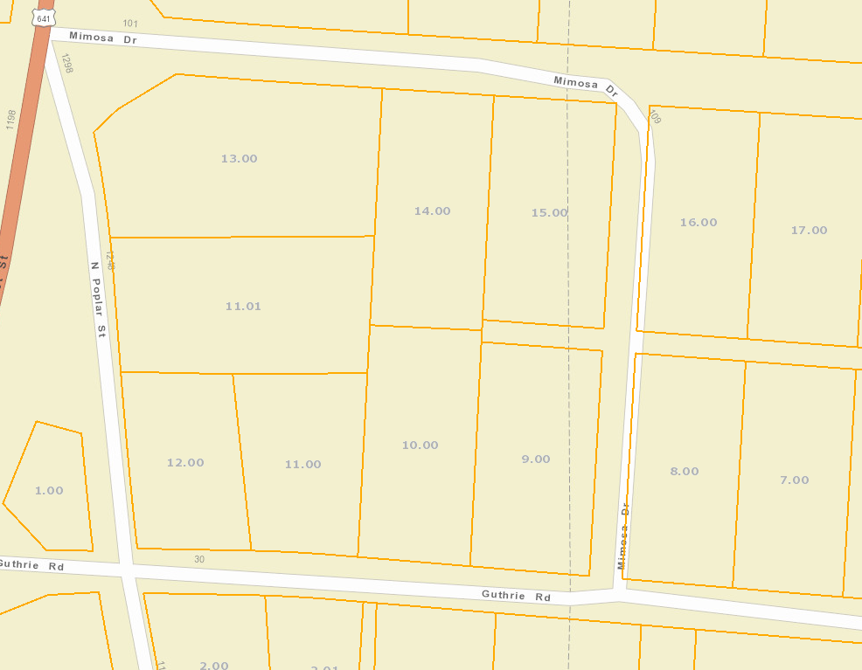
Undeveloped Alleyway
Parcels owned by Paul Harber

NEW BUSINESS
AGENDA ITEM NO.1
Financial Update

Narrative to November 2020 Operating Statement

Our retail sales tax revenue was up for the seventh month in a row. The month of October reflected an unbelievable 14.75% increase. We are now ahead 10.88% for our fiscal year-to-date.

General Fund revenues were ahead of expenditures for the month of November and we are now ahead fiscal year-to-date. Property tax revenue is finally rolling in and our sales tax revenue continues to increase. We did have a few large expenses in November which included $100K for three new patrol vehicles, $15K for repair of the track-loader, and $29K for our annual audit.

Sanitation and Landfill revenues are also ahead for our fiscal year-to-date.

Other Business:

New employees: One part-time (Civic Center Maintenance)
Resignation: None

We issued seen business licenses in November:
New Business (3): La Tour Salon, The Shop on Wood Street, Wild Willow Boutique
New Owner & Location: Sally Lane’s Candy Farm
New Owner: Take Me Back Restaurant LLC
Name Change: New Cingular Wireless (AT&T Mobility)
Add’l Location: Wicked Kolors LLC (Contractor from Clarksville)

CITY OF PARIS, TENNESSEE
RETAIL SALES TAX REVENUE
 |  |  |  |  |  |  | %
 | FY2017 | FY2018 | FY2019 | FY2020 | FY2021 |  | Incr(Decr)
JULY | $748,999 | $791,918 | $787,901 | $802,267 | $898,979 |  | 12.05%
AUGUST | $738,171 | $775,581 | $790,533 | $799,378 | $843,541 |  | 5.52%
SEPTEMBER | $791,866 | $812,873 | $774,425 | $797,992 | $888,921 |  | 11.39%
OCTOBER | $732,345 | $777,777 | $761,812 | $761,453 | $873,733 |  | 14.75%
NOVEMBER | $770,351 | $821,637 | $809,116 | $807,105
DECEMBER | $999,663 | $927,868 | $960,027 | $957,286
JANUARY | $674,764 | $689,391 | $665,013 | $713,906
FEBRUARY | $684,426 | $697,202 | $704,313 | $727,380
MARCH | $840,859 | $840,412 | $877,659 | $840,175
APRIL | $792,642 | $774,320 | $849,875 | $865,360
MAY | $796,500 | $840,600 | $863,697 | $949,140
JUNE | $871,656 | $849,365 | $873,145 | $966,861
TOTAL | $9,442,243 | $9,598,946 | $9,717,515 | $9,988,303 | $3,505,174
Previous YTD %
Increase/Decrease | 2.52% | 1.66% | 1.24% | 2.79% | 10.88%

MONTHLY OPERATING STATEMENT
NOVEMBER 2020

REVENUES |  | Annual Budget | Current Month | Yr to Date | Percent Realized
Property Taxes |  | 1,469,000 | 226,034 | 259,766 | 17.68%
Local Option Sales Tax |  | 4,550,000 | 435,066 | 2,225,661 | 48.92%
Wholesale Liquor / Beer |  | 790,000 | 69,699 | 403,830 | 51.12%
Business Tax |  | 360,000 | 10,507 | 79,175 | 21.99%
Fees & Licenses |  | 162,500 | 38,195 | 76,877 | 47.31%
In Lieu Payments |  | 876,250 | 88,649 | 299,377 | 34.17%
Grants |  | 1,779,475 | 248,895 | 679,736 | 38.20%
State Shared taxes |  | 1,366,000 | 121,963 | 660,286 | 48.34%
All Other |  | 4,898,664 | 103,554 | 783,047 | 15.98%
Total General Fund Revenue |  | 16,251,889 | 1,342,562 | 5,467,755 | 33.64%
Solid Waste Collection - BPU |  | 1,225,000 | 209,732.91 | 521,323 | 42.56%
Solid Waste Disposal - Transfer |  | 350,000 | 38,622 | 172,518 | 49.29%
Other Revenue |  | 400 | 4 | 144 | 36.03%
Total Sanitation |  | 1,575,400 | 248,359 | 693,985 | 44.05%
Gate Receipts - Brush & Debris |  | 120,000 | 20,397 | 70,394 | 58.66%
County Share Operating Exp |  | 35,000 | 0 | 0 | 0.00%
Gate Receipts - Tires |  | 12,000 | 461 | 872 | 7.27%
Other Revenue |  | 30,450 | 190 | 30,799 | 101.14%
Total Landfill |  | 197,450 | 21,049 | 102,065 | 51.69%
Total Drug Fund |  | 68,050 | 1,530 | 26,856 | 39.47%
TOTAL REVENUES |  | 18,092,789 | 1,613,500 | 6,290,661 | 34.77%

EXPENDITURES |  | Annual Budget | Current Month | Yr to Date | Percent Realized
Grants & Donations |  | 273,990 | 392 | 49,458 | 18.05%
General Administration |  | 371,814 | 28,954 | 149,140 | 40.11%
Economic Development |  | 124,264 | 9,779 | 48,284 | 38.86%
Elections |  | 4,500 | 0 | 0 | 0.00%
Financial Administration |  | 301,825 | 48,181 | 144,834 | 47.99%
City Hall Building |  | 94,689 | 7,027 | 39,958 | 42.20%
Police Department |  | 2,331,078 | 250,152 | 911,834 | 39.12%
Emergency Communications |  | 709,474 | 55,728 | 258,634 | 36.45%
Fire Department |  | 1,671,837 | 134,628 | 671,264 | 40.15%
Building Inspection |  | 91,502 | 5,568 | 36,981 | 40.42%
Street Maintenance |  | 1,598,399 | 89,831 | 579,871 | 36.28%
State Street Aid |  | 500,000 | 2,546 | 456,475 | 91.29%
Storm Water Management |  | 71,587 | 6,557 | 22,450 | 31.36%
Street Lighting |  | 102,000 | 4,237 | 27,783 | 27.24%
City Garage |  | 278,963 | 19,017 | 115,387 | 41.36%
Cemetery Maintenance |  | 61,124 | 548 | 34,240 | 56.02%
Health & Animal Control |  | 165,976 | 12,199 | 70,003 | 42.18%
Civic Center |  | 544,297 | 37,554 | 183,685 | 33.75%
Parks & Recreation |  | 997,395 | 65,484 | 360,502 | 36.14%
Library |  | 166,487 | 27,748 | 83,243 | 50.00%
Community Development |  | 5,385,400 | 15,886 | 893,521 | 16.59%
Debt Service |  | 823,546 | 18,651 | 176,914 | 21.48%
General Fund Expenditures |  | 16,670,147 | 840,666 | 5,314,462 | 31.88%
Sanitation Collection |  | 873,671 | 56,250 | 351,614 | 40.25%
Contractual Services |  | 630,000 | 47,887 | 259,337 | 41.16%
Total Sanitation |  | 1,503,671 | 104,137 | 610,950 | 40.63%
Total Landfill |  | 175,284 | 24,267 | 74,764 | 42.65%
Total Drug Fund |  | 100,900 | 1,843 | 18,081 | 17.92%
TOTAL EXPENDITURES |  | 18,450,002 | 970,913 | 6,018,258 | 32.62%

REVENUES OVER / (UNDER) EXPENDITURES |  |  | Current Month | Yr to Date
General Fund |  |  | 501,897 | 153,293
Sanitation |  |  | 144,222 | 83,035
Landfill |  |  | (3,218) | 27,301
Drug Fund |  |  | (313) | 8,775
NEW BUSINESS
AGENDA ITEM NO. 2
Appointment to Boards

BOARD | CURRENT MEMBER | PROPOSED MEMBER | TERM EXPIRATION | NEW EXPIRATION
Planning Commission/Board of Zoning Appeals (3 year term) (Mayoral appt./Exception: Commission appoints one Commissioner | Charlie West | Tara Wilson | August 6, 2021 | August 6, 2021
Planning Commission/Board of Zoning Appeals (3 year term) (Mayoral appt./Exception: Commission appoints one Commissioner | Carlton Gerrell | John Etheridge | August 2023 | August 2023
Alcoholic Beverage Control Board (3 year term) (Mayor w/Commission Approval) | Tara Wilson | James Matthew White | July 18, 2023 | July 18, 2023

NEW BUSINESS
AGENDA ITEM NO. 3
Audit Presentation

An audit presentation will be given by Matt Wood, CPA, Alexander, Thompson, Arnold.

NEW BUSINESS
AGENDA ITEM NO. 4
Ordinance to Delete Tit13, Chapter 1 of the Paris Municipal Code (First Reading)

The following ordinance being presented refers to the enabling legislation that authorizes creation of Paris Board of Public Utilities. The attached Ordinance deletes Title 13, Chapter 1 from our Municipal Code. This is merely a housekeeping measure to clean up our Municipal Code from any references to the City’s control of what is now known as Paris Utility Authority.

Ordinance No. ________________

AN ORDINANCE
to Delete Title 13, Chapter 1 of the Paris Municipal Code

SECTION 1. Be it ordained by the Board of Commissioners of the City of Paris, Tennessee that the Paris Municipal Code be amended by deleting in its entirety Title 13, Chapter 1.
(Ord. # _____________, ______ / ______ / 2020.

SECTION 2. All ordinances and parts of ordinances in conflict with the provisions of this ordinance are hereby repealed.

SECTION 3. This ordinance shall take effect on and after final passage and adoption.

Passed and adopted _____________________________.

Passed and adopted _____________________________.

_______________________________________
Mayor

________________________________________
Finance Director
NEW BUSINESS
AGENDA ITEM NO. 5
Reuqest to Write-Off Delinquent Property Tax

Following is a list of uncollectible Personal Property taxes ordered by Chancery Court on 9-21-20 to be dismissed.

Personal Property Tax Dismissals per Chancery Court 9-21-20
Map/Parcel | Business Name | Amount
106B-999-791.01-P | Haynes Medical Clinic | 5.00
095H-A-095H-020.00-P | Ultimate Concepts | 5.00
094A-B-094A-002.00-P | Barton Family Health Clinic | 69.00
106-106-032.01-P | Splattered Ink & Tattoos | 27.00
117-999-853.00-P | Scott Tire Co | 97.00
094-999-283.01-P | Nails By Misty | 1.00
106A-A-106A-010.00-P | Simply Detail | 2.00
116-999-109.02-P | St John Security Systems | 20.00
999-999-698.01-P | Mac Toddy's Barber Shop | 32.00
106O-B-106O-024.00-P | Perkins Transport | 102.00
 | Total | 360.00

NEW BUSINESS
AGENDA ITEM NO. 6
Ordinance to Rezone County Owned Property Located on Hwy 218 By-Pass

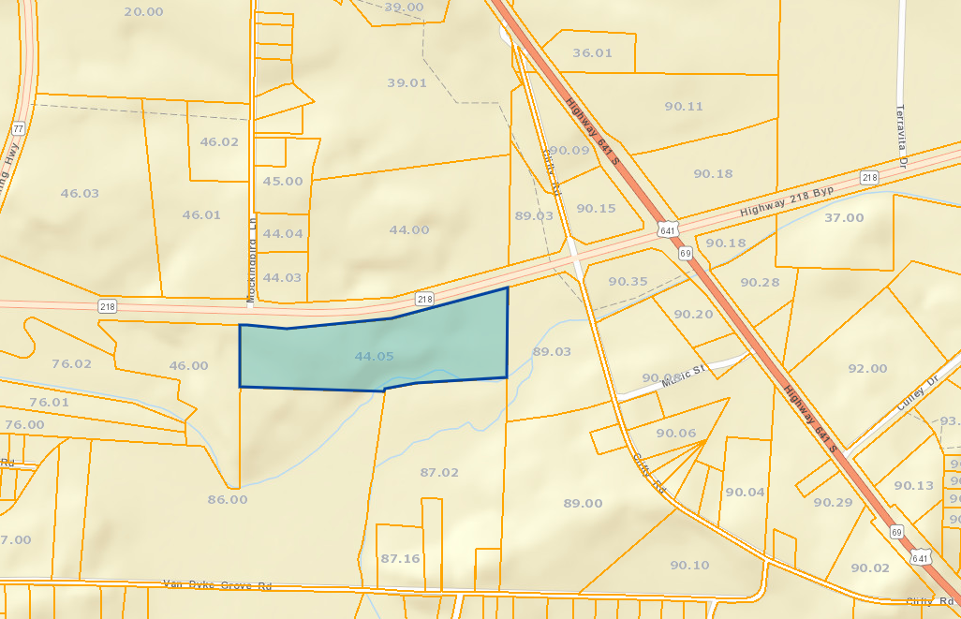
Henry County owns a 20 acre tract of property located on the south side of Highway 218 between Hwy 77 and Hwy 641 North, more specifically it is across from Mockingbird Lane. Currently this property is under review by the Paris Henry County Industrial Committee for marketing the property to prospects. In reviewing the property it was determined that it is zoned B-1 Highway Commercial. For this to be developed by any company or developer for any industrial/manufacturing type use it should be studied to determine which industrial zone would best fit this parcel.
The City Commission may wish to adopt an ordinance on first reading by caption to rezone parcel 44.05 of Map 116. Additionally, this item of business should be referred to the Planning Commission for recommendation.

STATUS OF VARIOUS PROJECTS
January 2021
 | PRIMARY STAFF | TARGET COMPLETION DATE(S)
HOME Grant | Morris/Foster | 2022 | We have received our executed contract and are now in the NEPA phase. This phase will take at least six months.
Back Alley Paris | Foster/Morris/  Ray(DPA) | June 2021 | The theme for this project is “celebrate Paris” and Dan Knowles is working on a prototype. We are hoping to locate this mural on the back of the Commercial Bank building so it is very visible from E. Wood St. Kathy Ray is in negotiations with the bank.
TA Grant for Sidewalks along Wilson & Patriot | Foster/Morris | Spring 2022 | Preliminary acquisition notices were sent to property owners in Dec. We will be contacting the property owners during the month of January to try to finalize right-of-way acquisition. Utility Coordination package submitted to TDOT and approved. TLM has begun work on final Construction Drawings. Final Construction Drawings 90% complete.
2018 STBG Project for Signalization & Safety Upgrades at 3 Intersections Downtown | Foster/Morris | Spring 2022 | Final NEPA document was sent to TDOT in August, we are still waiting on their approval. TLM continues to work on preliminary layout. TLM has also begun coordination with TDOT on Wood Street intersections that will be reworked by TDOT as part of TDOT paving project.
Rison St Bridge Replacement | Foster/Morris | Fall 2021 | The final NEPA document with all requested edits was submitted to TDOT mid-November. We are still waiting for their final approval and NTP.
2019 Tourism Enhancement Grant for Eiffel Tower Upgrades | Foster/Morris/  Lawrence | Fall 2020 | The sign pole has been capped and looks fantastic! Based on our application we have completed the project but because we came in quite a bit under the anticipated budget we are trying to get TECD to allow us to use the extra money to purchase some benches or garbage cans.
2019 Multimodal Access Grant for 4 Downtown Intersections | Foster/ Morris | Spring 2022 | TDOT is still considering an abbreviated NEPA document instead of a full review since a full review was done on the project area for the STBG project. They have had all documentation since August, we are still waiting on word from them. Preliminary design has begun. TLM coordinating with TDOT paving project with regards to intersection of Wood and Market.
BCBS Healthy Place Grant | Morris/Lawrence | Summer of 2021 (if awarded) | We were awarded this grant! We are waiting to receive the contract. Representative from BCBS should be on-site to review location and site prep needs soon. They are hoping to begin construction in March.
2020 TA Grant for Sidewalk Project along Fairgrounds & Royal Oak | Foster | Winter of 2023 (if awarded) | Grant application was submitted, award announcements will probably not come until summer of 2021.
Drainage Improvements | Foster/Morris/  Schrader | Ongoing | Patrick Smith, P.E., will be submitting recommendations of appropriate changes to our development standards & subdivision regs. He is also working on a drainage project to be submitted for a CDBG grant. Deadline for application is Feb. 2021. NWTDD will be the grant administrator. We can apply for up to $420,000 and our match will only be 10%.

